Exp No. -2 Create a simple cloud software application for Property Buying & Rental process (In Chennai city) using any Cloud Service Provider to
demonstrate SaaS

Done by: Juhi Surin
Register no.: 192525148

Aim:
To develop a cloud-based SaaS application for property buying and rental management in Chennai using Zoho Creator.

Procedure:
- Log in to Zoho Creator and create a new application named CloudNest – Property Buying & Rental System.
- Create a form called Property_Details and add all the required fields.
- Configure dropdown values for Property Type, Location, and Availability.
- Create an On Success workflow using Deluge to display messages based on the property type and price.
- Enter sample property records and submit the form to store the data.
- View the saved records in the report and verify that the workflow executes successfully, demonstrating a cloud-based SaaS application.

Implementation Steps:
Step 1: Log in to Zoho Creator and create a new application.
Step 2: Create a form named Property_Details and add the required fields.
Step 3: Configure the dropdown fields for Property Type, Location, and Availability.
Step 4: Create an On Success workflow using Deluge to process property details and display messages.
Step 5: Enter sample property records and submit the form to store the data in the cloud.
Step 6: Open the report, verify the stored records, and test that the workflow executes successfully.
Output:
- Form
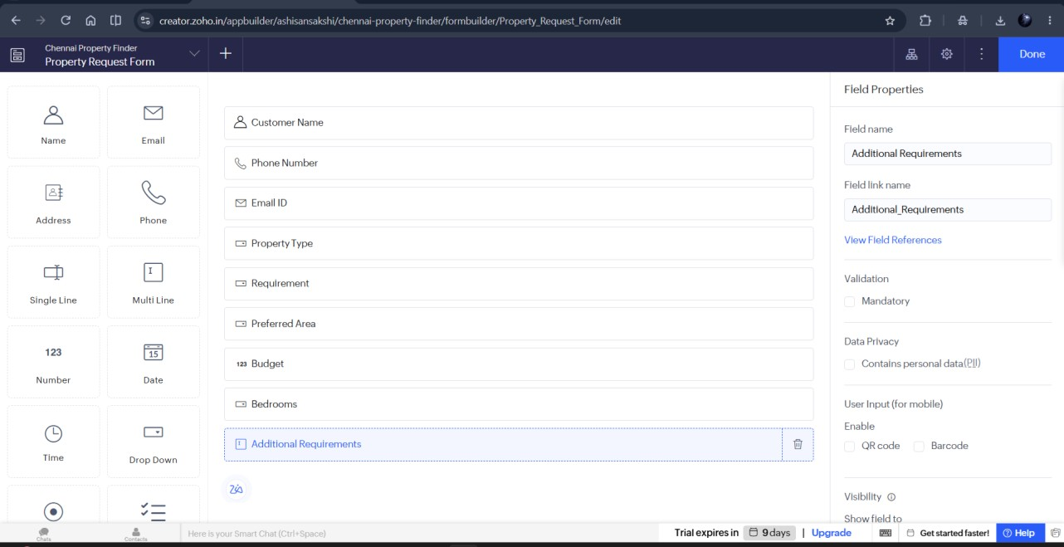

- Workflow
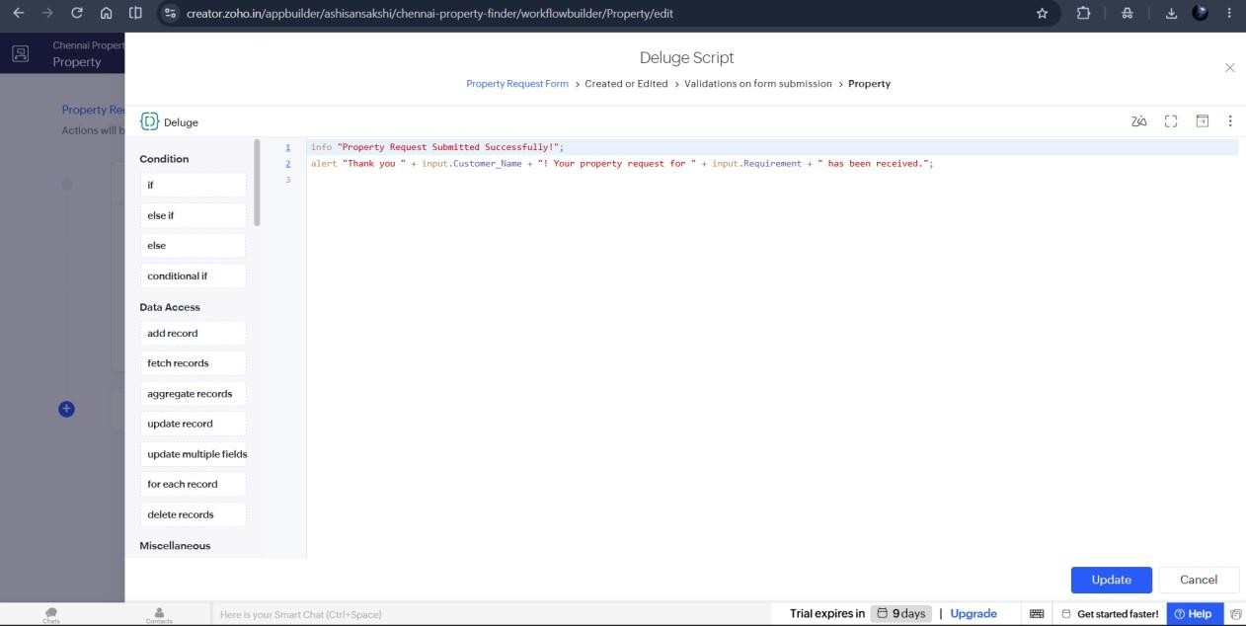

- Report
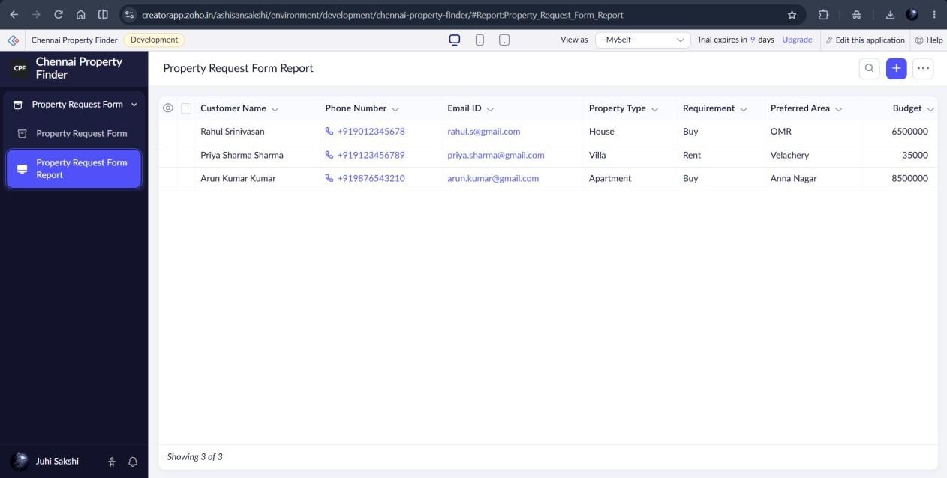

Result:
The cloud-based Property Buying & Rental Management System was successfully implemented in Zoho Creator.

